Calculus Related Rates practice problems

Try and complete these problems without going back to your homework examples.

1. Water is flowing into a cone shaped tank at the rate of 5 in³/s. If the cone has a height of 4 inches and radius of 3 inches how fast is the water level rising when the water is 2 inches deep?

2. Find the rate of change of the height of the triangular trough when the height is 3ft. The trough is filling at a rate of 2ft³/min. The trough has a height of 6 ft a width of 3ft and a length of 14ft.

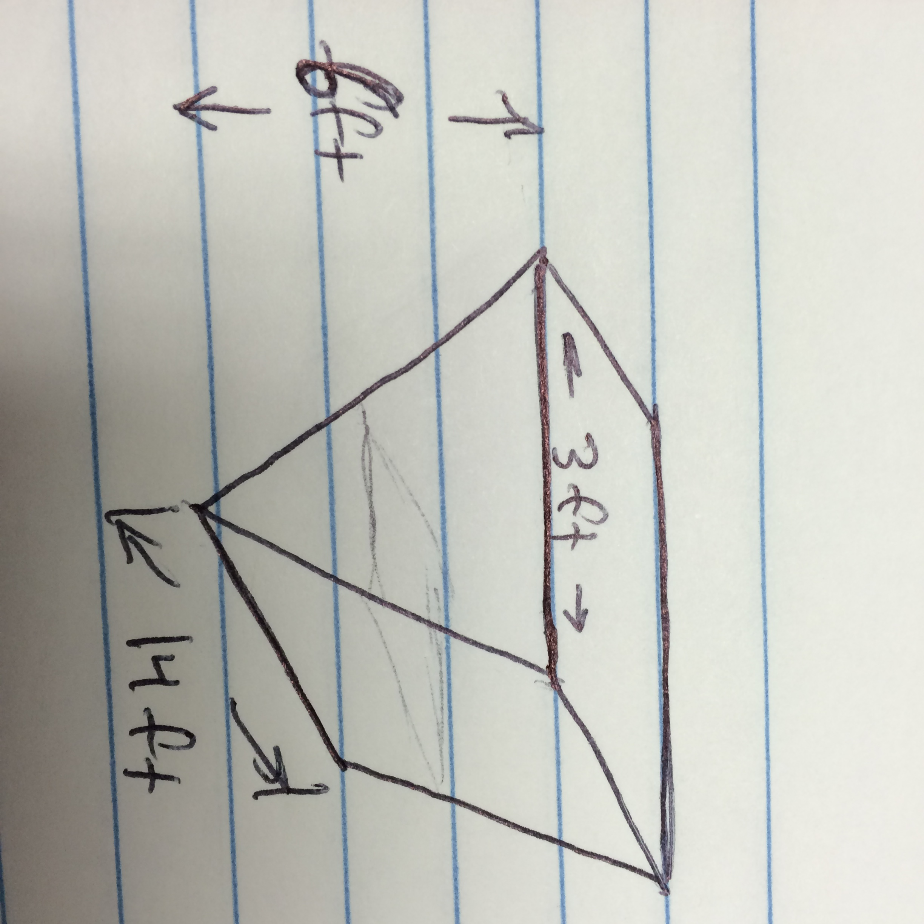

3. A 41 ft ladder is leaning against a vertical wall. The top of theladder is sliding down the wall while the bottom slides along the ground away from the wall at 4ft/s. How fast is the top moving when it is 9 ft above the ground?

4. A spherical balloon is inflated with gas at a rate of 20ft3/min. How fast is the radius of the balloon increasing at the instant when
a) the radius is 1ft
b) the radius is 2ft

5. A water tank has the shape of a cylinder with the base radius 2m and the height 4m. If the water is being pumped into the tank at a rate of 2m³/min, find the rate at which the water lever is rising when the water is 3m deep.

