Calculus Related Rates Quiz 1/31/14

1. Air is being pumped into a spherical balloon at a rate of 5 cm³/min. Determine the rate at which the radius of the balloon is increasing when the diameter of the balloon is 20cm.

2. Two people are 50 ft apart. One of them starts walking north at a rate so that the angle shown in the diagram below is changing at a constant rate of 0.01 rad/min. At what rate is the distance between the two people change when Theta = 0.5 radians?
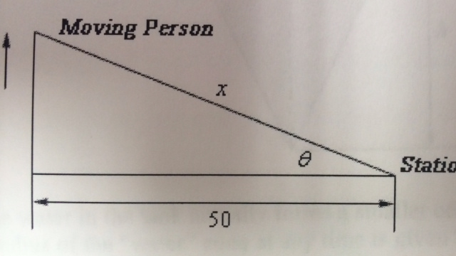

3. A tank of water in the shape of a cone is leaking water at a constant rate of 2ft³/hour. The base radius of the tank is 5ft and the height of the tank is 14ft.
a) At what rate is the depth of the water in the tank changing when the depth of the water is 6ft?

b) At what rate is the radius of the top of the water in the tank changing when the depth of the water is 6ft.
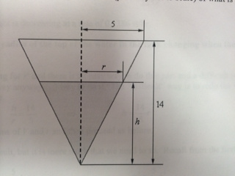

4. A trough of water is 8 meters deep and its ends are in the shape of isosceles rectangles whose width is 5 meters and height is 2 meters. If water is being pumped in at a constant rate of 6m³/sec. At what rate is the height of the water changing when the water has a height of 120 cm?

